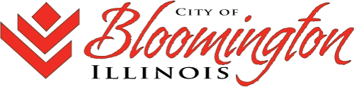

COVID-19 DIRECT AID TO RESIDENTS PROGRAM
BACKUP DOCUMENTATION LIST

As a condition of receiving financial assistance through the Community Development Block Grant (CDBG), a federally funded program, you must provide backup documentation to verify identity, income and crisis occurring as a result of the COVID-19 pandemic. Please include the items below with your application:

Identification Verification
For anyone whose name appears on the lease agreement, mortgage, utility bill or medical bill for which assistance is being requested:

- Copy of Photo ID
- Copy of Social Security Card

Income Verification – Submit all that apply
For anyone whose name appears on the lease agreement, mortgage, utility bill or medical bill for which assistance is being requested:

- Past 3-months bank statements – checking and savings
- Most recent tax return
- Last (3) paycheck stubs
- Proof of unemployment filing including approval/denial letter, if appropriate
- Proof of SSI/SSDI Income
- Other proof of income

For all additional household members age 18 and over, submit all that apply:
- Last (3) paycheck stubs
- Proof of unemployment filing including approval/denial letter
- Proof of SSI/SSDI Income
- Other proof of income

Crisis Documentation – Submit all that apply
- Crisis Verification form – included with application
- Rental Assistance – Late notice from landlord, Eviction Notice or Rental Arrears form (link)
- Mortgage Assistance – Late notice from lending institution or Mortgage Arrears form (link)
- Utility Assistance – Late notice from utility company, Disconnect Notice, or Utility Arrears form (link)
- Medical Assistance – Copy of bill dated after March 17, 2020 and statement indicating inability to pay
- Child Care Assistance – Denial notice from the Child Care Assistance Program

If you are unable to provide copies of the above documents for submission with your application, copies can be made for you. Please visit the Citizen Convenience Center at the Grossinger Arena (Front and Madison) for assistance.

For questions related to the application or required documentation, please contact covid19assistance@cityblm.org or 434-2909.

