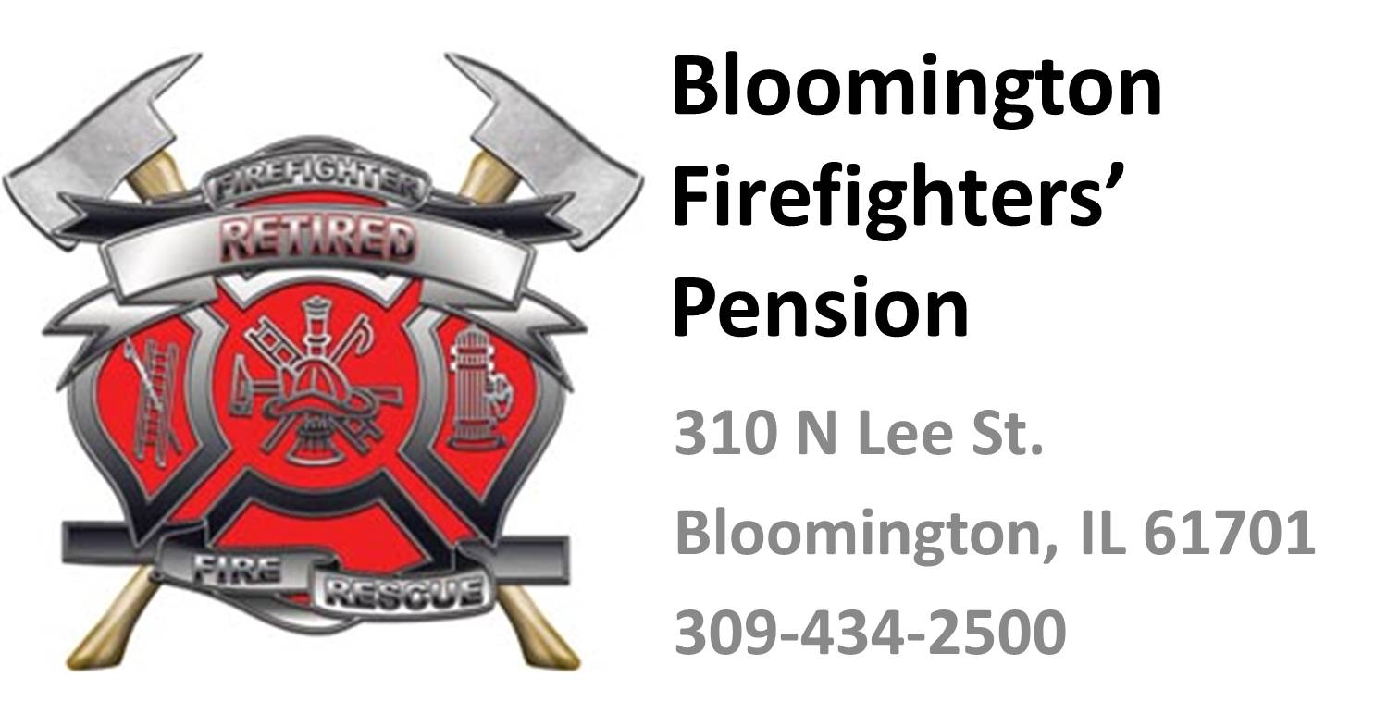
Bloomington Firefighters’ Pension Fund

AGENDA

310 N. Lee St., Bloomington, IL 61701

Ronald E. Fowler, President Carl R. Reeb, Secretary

THE QUARTERLY MEETING OF THE BLOOMINGTON FIREMENS PENSION BOARD WILL BE HELD ON FRIDAY, JANUARY 24, 2020 AT 2:00 PM AT STATION 6, 4040 E. OAKLAND AVE.

- CALL TO ORDER

- ROLL CALL

- PUBLIC COMMENT
  - Limit of 3 minutes per comment with no more than 2 comments in the same subject,
  - Max of 5 persons per meeting

- APPROVAL OF MINUTES
  - Recommend that the Minutes of the October 2019 meeting be approved as presented.

- TREASURES REPORT (Roll Call vote)
  - Recommend payment to contracted firms for services as billed for the ensuing quarter
  - Review bills paid during the previous quarter and place on file for audit
  - Recommend that current the bills be approved and placed on file for audit.
  - Recommend approval of the Quarterly Payroll Report as prepared by Insight
  - Recommend approval of the Quarterly Financial reports as prepared by Insight

- FINANCIAL INVESTMENT REPORT (Roll Call vote)
  - Review investment activity and recommendations,
  - Approve funds investment after consideration of recommendations
by Wall Financial Group, investment adviser.

- COMMUNICATIONS
  - Upcoming Training Events

- APPLICATION TO THE FUND (Roll Call vote)
  - None

- WITHDRAWL FROM THE FUND (Roll Call vote)
  - Hursey, Quentin
  - Lanhardt, James
  - Macdonald, Kyle

- APPLICATION FOR RETIRMENT/DIABILITY (Roll Call vote)
  - Gene Berkley

- OLD BUISNESS
  - Review completed with Insight for Benefits and COLA increases
  - Approve 2020 Meeting Dates

- NEW BUSINESS
  - 1099R and 1099MISC will be postmarked by 1/31 as prepared by Insight
  - Review contract for Audit Services
  - Review contract for Actuary
  - Approve initiation of election process for trustee.
    - Nominations completed in March
    - Election to be held third Monday in April.

- ADJOURMENT

