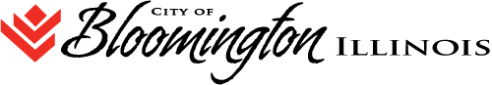

**HUMAN RELATIONS COMMISSION REGULAR AGENDA**

**109 E. OLIVE STREET. Bloomington, IL**

**Council Chambers**

**WEDNESDAY, DECEMBER 12, 2018 at 6:00 P.M.**

1. Call to Order
2. Roll Call of Attendance
3. Public Comment
4. Approval of Minutes:
   1. Consideration of approving the minutes of the Human Relations Commission Special Meeting of Monday November 19, 2018.
   2. Move to closed session for consideration of approving the minutes of the Closed Session meeting of November 19, 2018
5. **Agenda Items**
   1. Progress report on MLK Event activity
6. Old BusinessStatus of discrimination complaint
7. New BusinessTicket distribution to Commissioners
8. **Next Scheduled Meeting Date: January 9, 2019**
9. **Adjournment**